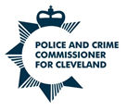Police and Crime Commissioner for Cleveland

Delay in publishing Audit Certificate: Year Ended 31 March 2023

The external audit of the Statement of Accounts for the year ended 31 March 2023 has been completed by our external auditors, Mazars LLP and the Independent Auditors report was issued on 27th June 2024. An unqualified opinion has been issued.

The audit certificate will be issued once the external audit of the whole of government accounts has been completed.

Under Regulation 10 of the Accounts and Audit Regulations 2015 (SI 2015/234) https://www.legislation.gov.uk/uksi/2015/234/regulation/10 , as amended by the Accounts and Audit (Amendment) Regulations 2021 (SI 2021/263) https://www.legislation.gov.uk/uksi/2021/263/regulation/2/made , the following have now been published on the website of the Police and Crime Commissioner:
- The Statement of Accounts together with any certificate or opinion entered by the local auditor in accordance with section 20(2) of the Act;
- The Annual Governance Statement approved in accordance with regulation 6(3); and
- The Narrative Statement prepared in accordance with regulation 8 (note that this is included in the Statement of Accounts)

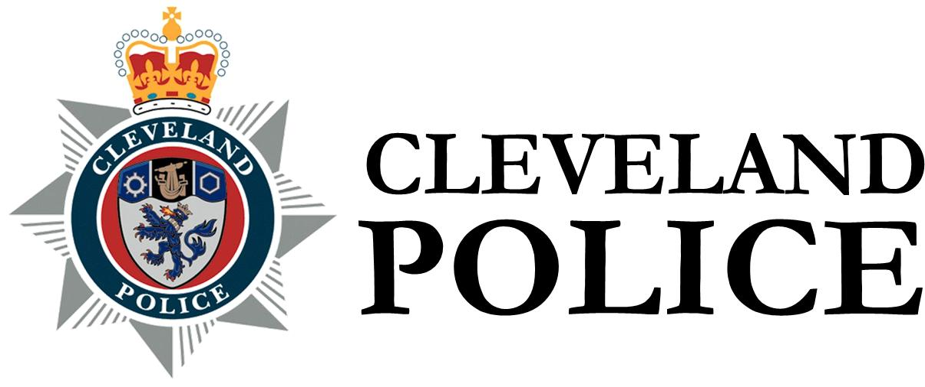 | Chief Constable for Cleveland

Delay in publishing Audit Certificate: Year Ended 31 March 2023

The external audit of the Statement of Accounts for the year ended 31 March 2023 has been completed by our external auditors, Mazars LLP and the Independent Auditors report was issued on 27th June 2024. An unqualified opinion has been issued.

The audit certificate will be issued once the external audit of the whole of government accounts has been completed.

Under Regulation 10 of the Accounts and Audit Regulations 2015 (SI 2015/234) https://www.legislation.gov.uk/uksi/2015/234/regulation/10 , as amended by the Accounts and Audit (Amendment) Regulations 2021 (SI 2021/263) https://www.legislation.gov.uk/uksi/2021/263/regulation/2/made , the following have now been published on the website of Cleveland Police:
- The Statement of Accounts together with any certificate or opinion entered by the local auditor in accordance with section 20(2) of the Act;
- The Annual Governance Statement approved in accordance with regulation 6(3); and
- The Narrative Statement prepared in accordance with regulation 8 (note that this is included in the Statement of Accounts)

Michael Porter
Chief Finance Officer and Deputy Chief Executive
Police and Crime Commissioner for Cleveland
Community Safety Hub
1 Cliffland Way
Hemlington
Middlesbrough
TS8 9GL

Date: 2 July 2024

